Code:

//Addition of two matrices

#include<stdio.h>

int main()

{

int a[100][100],b[100][100],c[100][100],r1,c1,r2,c2,i,j;

printf("Enter the row and columns of first matrix\n");

scanf("%d %d",&r1,&c1);

printf("Enter the row and columns of second matrix\n");

scanf("%d %d",&r2,&c2);

printf("Enter the elements of the first matrix \n");

for(i=0;i<r1;i++)

for(j=0;j<c1;j++)

scanf("%d",&a[i][j]);

printf("Enter the elements of the second matrix \n");

for(i=0;i<r2;i++)

for(j=0;j<c2;j++)

scanf("%d",&b[i][j]);

for(i=0;i<r1;i++)

for(j=0;j<c1;j++)

c[i][j]=a[i][j]+b[i][j];

for(i=0;i<r1;i++)

{for(j=0;j<c1;j++)

printf("%d\t",c[i][j]);

printf("\n");

}

return 0;

}

Output:

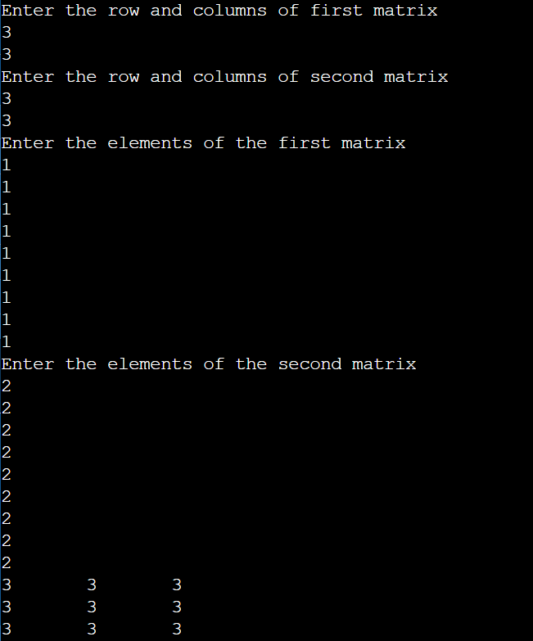

Conclusion: Addition of two matrices was successfully studied and implemented in C language.